# **SQL Query Assignment - 2**

1. Find out the number of documentaries with deleted scenes.

Query:

select count(c.name) as number_of_documentaries_with_deleted_scenes from film f

join film_category fc on f.film_id=fc.film_id

join category c on c.category_id=fc.category_id

where c.name='documentary' and

LOCATE('DELETED SCENES',special_features)!=0;



2.Find out the number of sci-fi movies rented by the store managed by Jon Stephens

Query:

select count(c.name) as number_of_scifi_rented from category c

join film_category fc on c.category_id=fc.category_id

join inventory i on i.film_id=fc.film_id

join staff st on st.store_id=i.store_id

where st.first_name='JON' and st.last_name='STEPHENS'

and c.name='sci-fi';

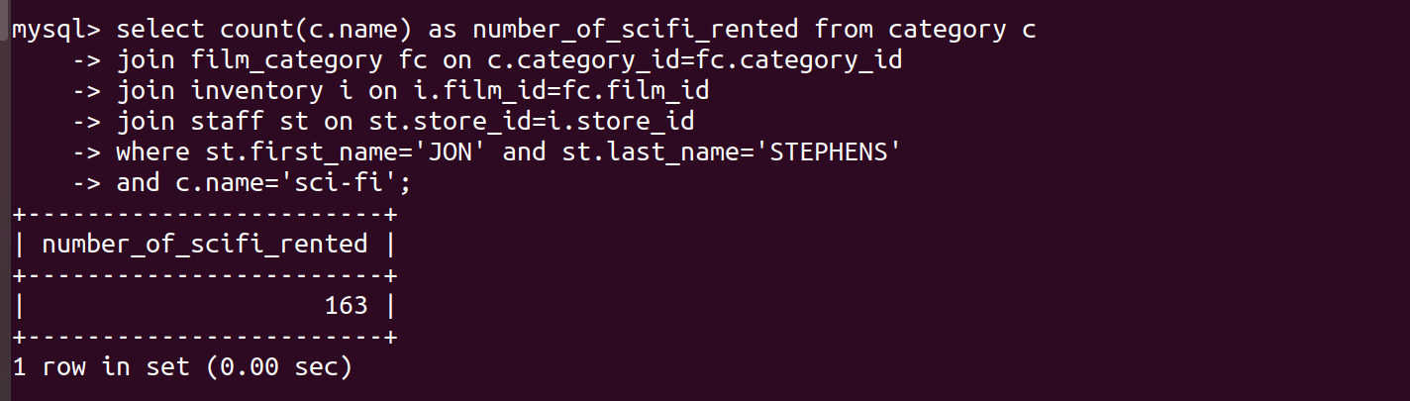

3. Find out the total sales from Animation movies.

Query:

select sum(amount) as total_sales_of_Animation from payment p

join rental r on p.rental_id=r.rental_id

join inventory i on i.inventory_id=r.inventory_id

join film_category fc on fc.film_id=i.film_id

join category cat on cat.category_id=fc.category_id

where cat.name='Animation';

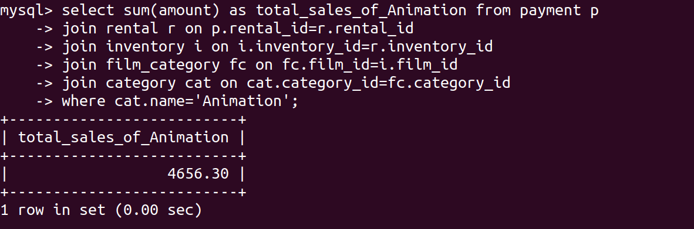

4. Find out the top 3 rented category of movies by “PATRICIA JOHNSON”.

Query:

select c.name as top_3_rented_categories from category c

join film_category fc on c.category_id=fc.category_id

join inventory i on i.film_id=fc.film_id

join customer cust on cust.store_id=i.store_id

where cust.first_name='PATRICIA' and cust.last_name='JOHNSON'

group by c.name order by count(c.name) desc limit 3;

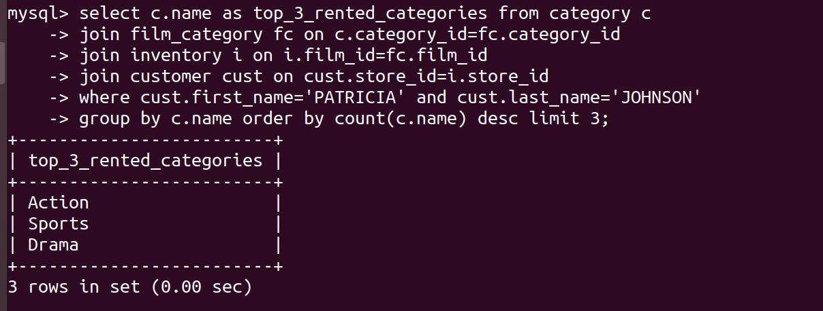

5. Find out the number of R rated movies rented by “SUSAN WILSON”.

Query:

select count(rating) as number_of_R_rated_movies from film f

join inventory i on i.film_id=f.film_id

join customer cust on cust.store_id=i.store_id

where cust.first_name='SUSAN' and cust.last_name='WILSON'

group by rating having rating='R';

